# Name: Tran Huu Hoang

Group member: Tran Huu Hoang

Le Tan Khang

Nguyen Dinh Le Dan

Nguyen Doan Hoang Lam

# **Introduction**

Telegram is a free messaging service popular world-wide, especially in Singapore. Just like Facebook Messenger or Whatsapp, it provides secure communication between two or more people totally free of charge. However, what makes Telegram stands out is the ability to create bots, “users” which can reply automatically and instantly with pre-coded responses and behaviours. This feature enables endless possibilities for Telegram, from checking Youtube videos to ordering eBay while sending gif to your friends. It also allows us to create our TrafficBot, a bot which helps users check the traffic condition for proper trip planning.

# **Problem Statement**

Commuting is an essential part of modern society. On average a Singaporean spends 9 hours each week driving[1], which equals to about 468 hours yearly. 87 of them are just drivers waiting in traffic jams[2], accounting for more than 18% the total time. While many of them are simply inevitable, some can be easily avoided by choosing alternate routes.While Singapore provides a fairly exact and in-time database of traffic condition, accessing it may take some time, not to mention in rush hour the amount of information can be overwhelmed, which makes it difficult to find your desired information.

**Proposed solution**

Introducing Chicken Rice Traffic Bot. It makes use of the Singapore Traffic Database and provides users with useful information on traffic quickly and conveniently. The bot is Python-coded with Telepot as its controlling API and Selenium as its main information collecting tool. It is designed to be highly interactive, making the process faster and more sastifactory.

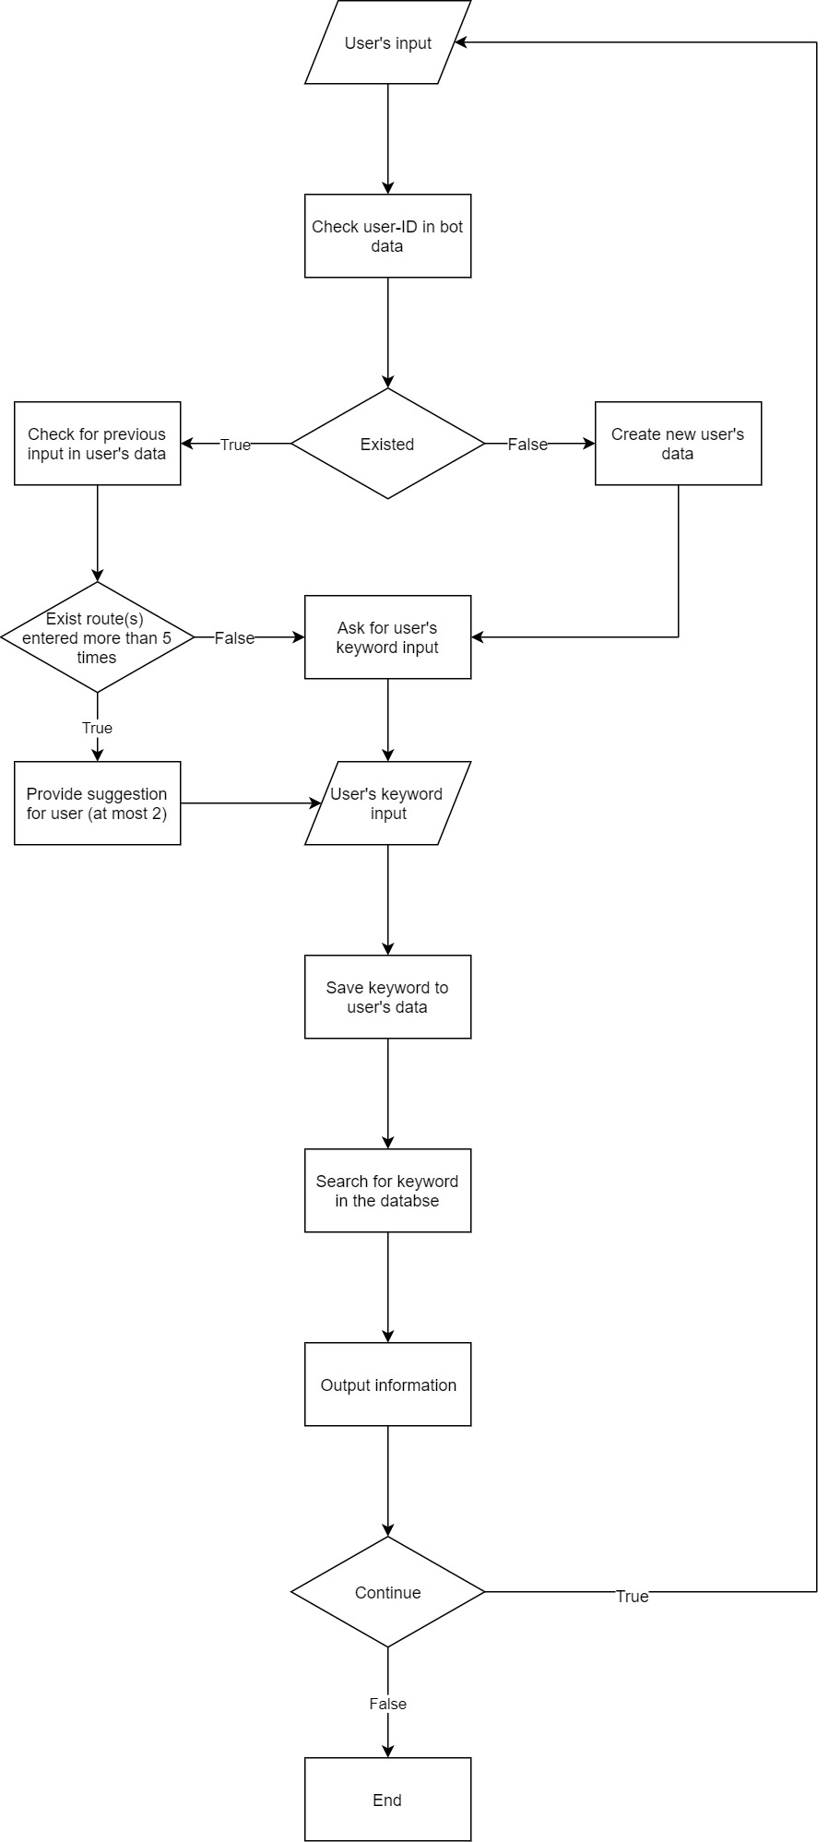

* Upon receiving message, the bot will respond.
* The user will then input the name of their intended route, which will be searched and output.

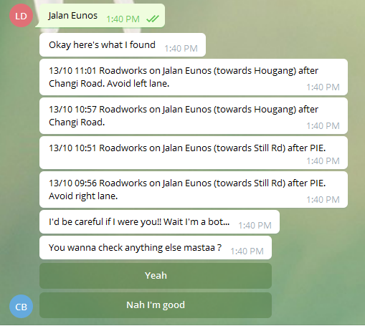

* The user can then choose whether to continue or not by pressing the button.



* After searching several times the same keywords, the bot will add it to its suggested button, making the process even faster.



# **Constraints and Limitations**

The TrafficBot has three limitations:

* TrafficBot uses the input keywords to check with its database. While it does not provide spelling correction, users might have to input the correct keywords with proper cases otherwise it won’t be able to find a match.

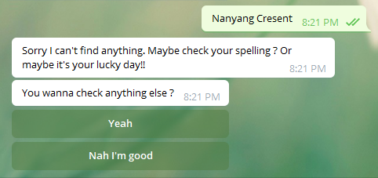

* The bot operates by cross-referencing the keyword with the Singapore traffic database website, therefore, when the website is shutdown or overload, TrafficBot will not be able to operate properly.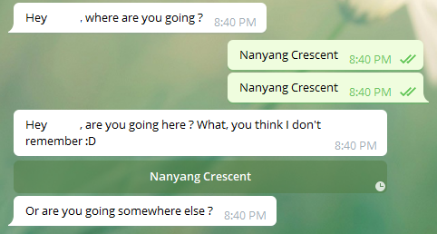
* Users might have to follow a given sequence of interactions in order to use the bot conveniently:

.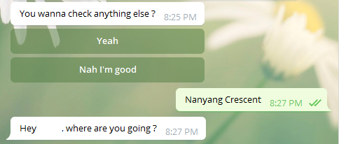

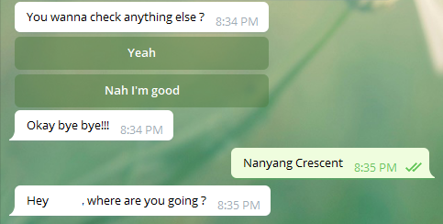

User need to choose 'Yeah' before entering the search term

# **Conclusion**

With commuting being an essential part of life, commuting quickly and efficiently can save a lot time and money while preventing frustration. TrafficBot provides a great way to achieve it. Using frequently-updated database, it can give users useful information on road condition. They can use that information to plan their trip properly, which will essentially save time and effort. TrafficBot is a great additional to the currently existed Telegram bots.